Game Meat / Viande de gibier
Elk / Wapiti
Sausage sticks / Bàtonnets de saucissons
Ingredients: Domestic elk, Pork, Beef, Sea salt, Sugar (maple syrup), Cultured celery powder, Pepper, Garlic, Starter culture, Olive oil, Natural wood smoke.
Ingredients: Wapiti domestique, Porc, Bœuf, Sel de mer, Sucre (sirop d’erable), Poudre de céleri de culture, Poivre, Ail, Culture starter, Huile d’olive, Fumée de bois naturel.

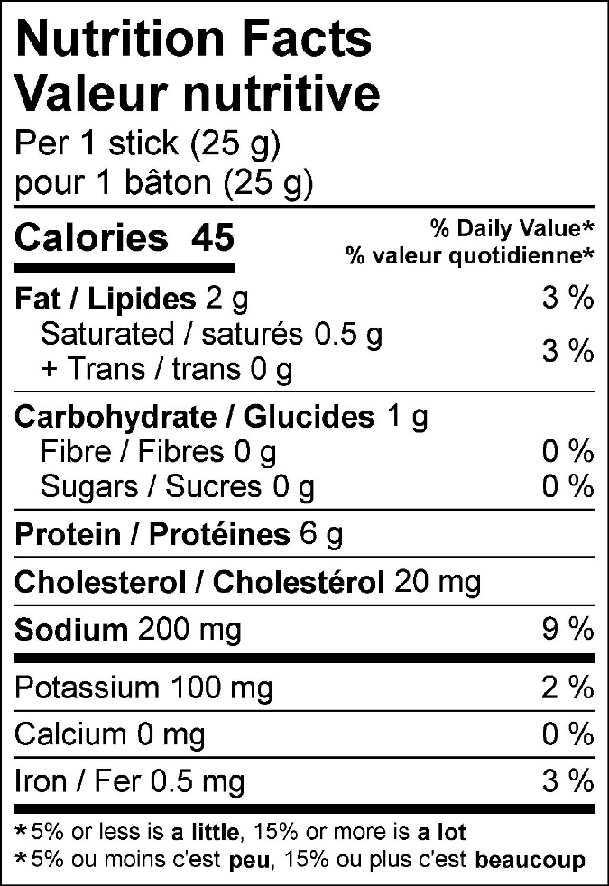

50 g (2-pack) 125 g (5-pack)
